First Steps with S-PAY
A step by step guide for new customers
Version 1.00

Content
Introduction 3
Signing Up 3
Notes regarding our registration form: 5
Notes regarding your personal activation email: 5
The first log-in to your customer account 6
Important note regarding your online banking: 8
Creation of a new currency account 8
Notes about account currency: 10
Notes regarding account numbers: 11
Deposits to your S-PAY currency accounts: 11
Notes regarding exchangers: 12
The first transaction: 12
Notes regarding internal transactions: 14
Closing words 15

Introduction
This tutorial is targeted to new customers who never did have any kind of usage with our online payment system S-PAY. We will show you what to do to get the most out of our system. Therefore we will show you step by step starting from the sign up process until your first internal remittance. If you still face questions after reading this guide carefully you are always welcome to contact our friendly support team by visiting https://service.s-pay.me .

Signing Up
To effectively work with S-PAY your firstly need a new customer account. To create your personal or corporate account visit https://www.s-pay.me and click the link which called “REGISTER ACCOUNT”.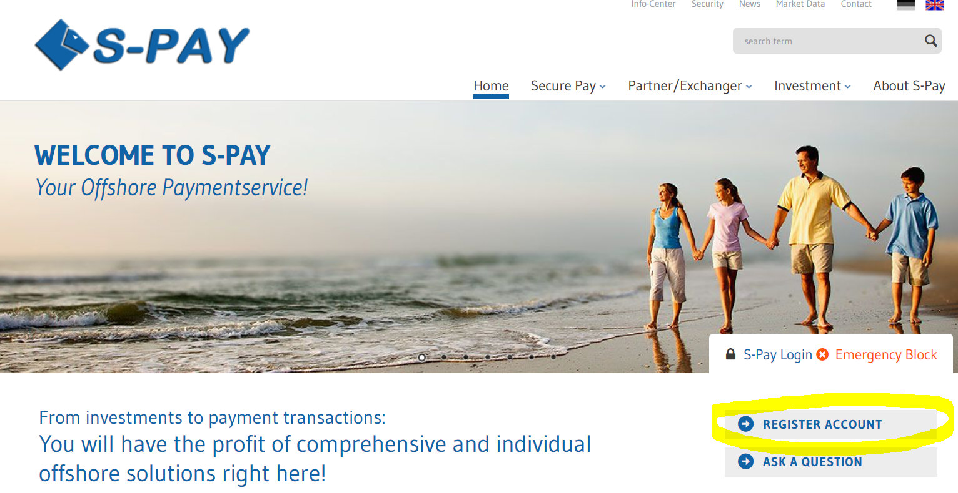
After clicking the ling you will be forwarded to our registration page. Now put in all necessary information in the fields which are marked with a, asterisk (*). If you were referred to our website by another customer you will also find his referral ID right down under the birthday entry form. If this is not the ID you have been given from your up-line you probably visited our website at least once before with another referral ID. Referral ID start with E, U, A or B. S-PAY stores the referral ID in a so called cookie directly at your computer. If you see another referral ID as you have been given you should close your browser and clean up your cookies with tools like in example Ccleaner powered by Piriform.com
After cleaning up your cookies and visiting the given link again the correct referral ID should be displayed now. The following picture shows the whole registration page:
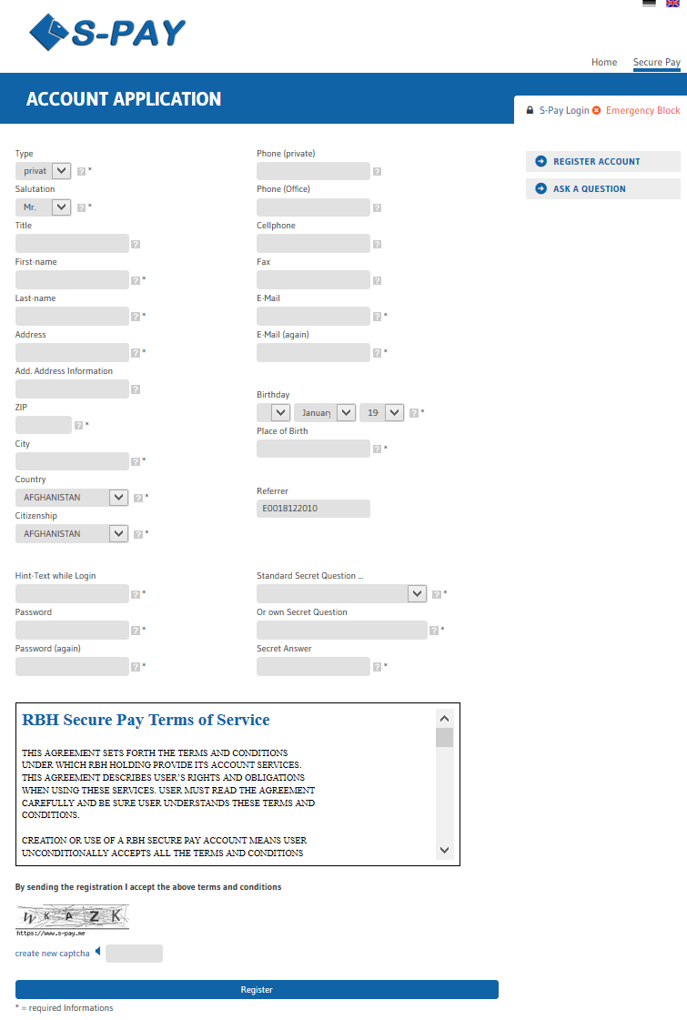

Notes regarding our registration form:
- Please write down the password you used at our registration page. This password is in need to log-in to your S-PAY account and WILL NOT be sent in your activation email!
- To finish the sign up process you will be forced to enter a short captcha code. This code just consists of alphabetic characters and never includes any numeric ones. The signs which are shown on the captcha can always be entered in lower capital format. If the current captcha is hard to read for your simply click on “create new captcha” and you will receive a new one. Also you are able to listen to an audio version of the captcha by clicking on the little speaker icon. Make sure your speakers are turned on! The same also works at the log-in form to your online banking.
- Behind the forms you will find little question marks. If you hover those ones with your mouse you are able to read short help-texts which also gives you information what to enter.

After filling out the necessary fields simply click on “Register” at the bottom of the page. If the system determines any errors the related fields are marked with a red border now and additionally an error message will be shown directly above the sign up forms. Correct the errors bordered in red, fill in the new captcha code and click “Register” again. If all was correct this time you will receive an activation letter sent by email and the following site will be shown:
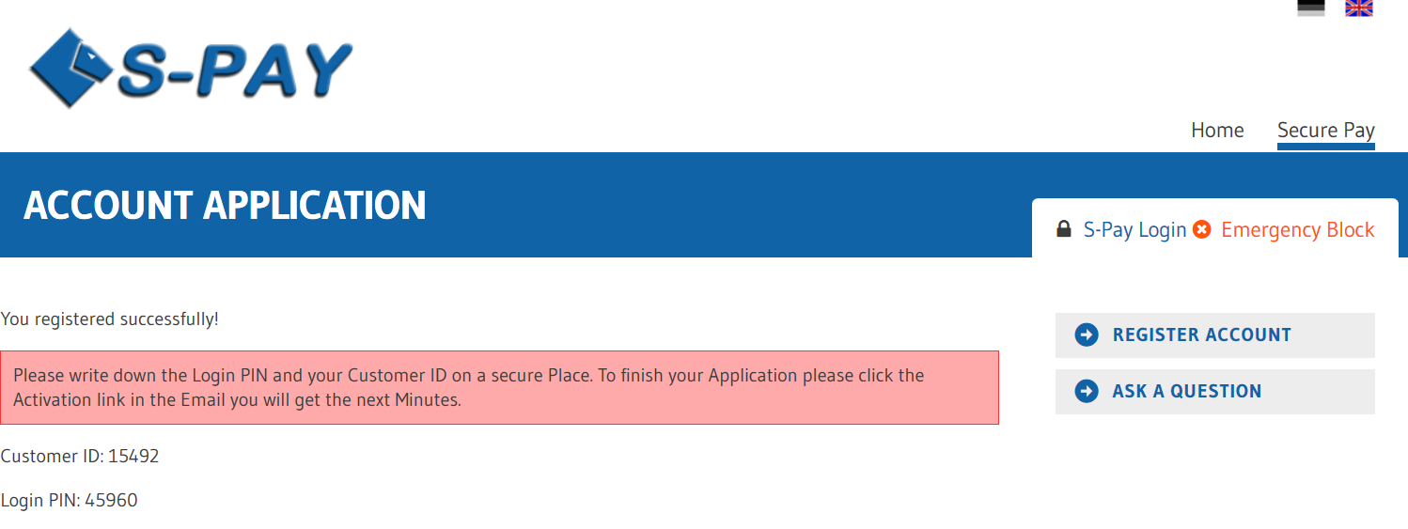

Notes regarding your personal activation email:
- Please write down the shown account number and Login-PIN. If you did not receive any activation mail against expectation you will need this information to log-in to your account after a manually activation.
- If you did not receive any activation email within several minutes make sure you also check your spam folder. If you use a local mail software to retrieve emails at your own computer (MS Outlook, Mozilla Thunderbird, …) make sure to log-in directly at the website of your provider and check the spam folder. If found please add S-PAY as a personal contact so that further emails will be white-listed and not moved to a spam folder anymore.
- If you still did not receive any activation mail please refer to contact our support team by using the ticket system. We will then activate your customer account manually so that you are able to log-in with the data written down before.

The first log-in to your customer account
After successful registration and activation of your newly created account you are now able to log-in the first time ever. Therefore on our portal page click “S-Pay Login”:
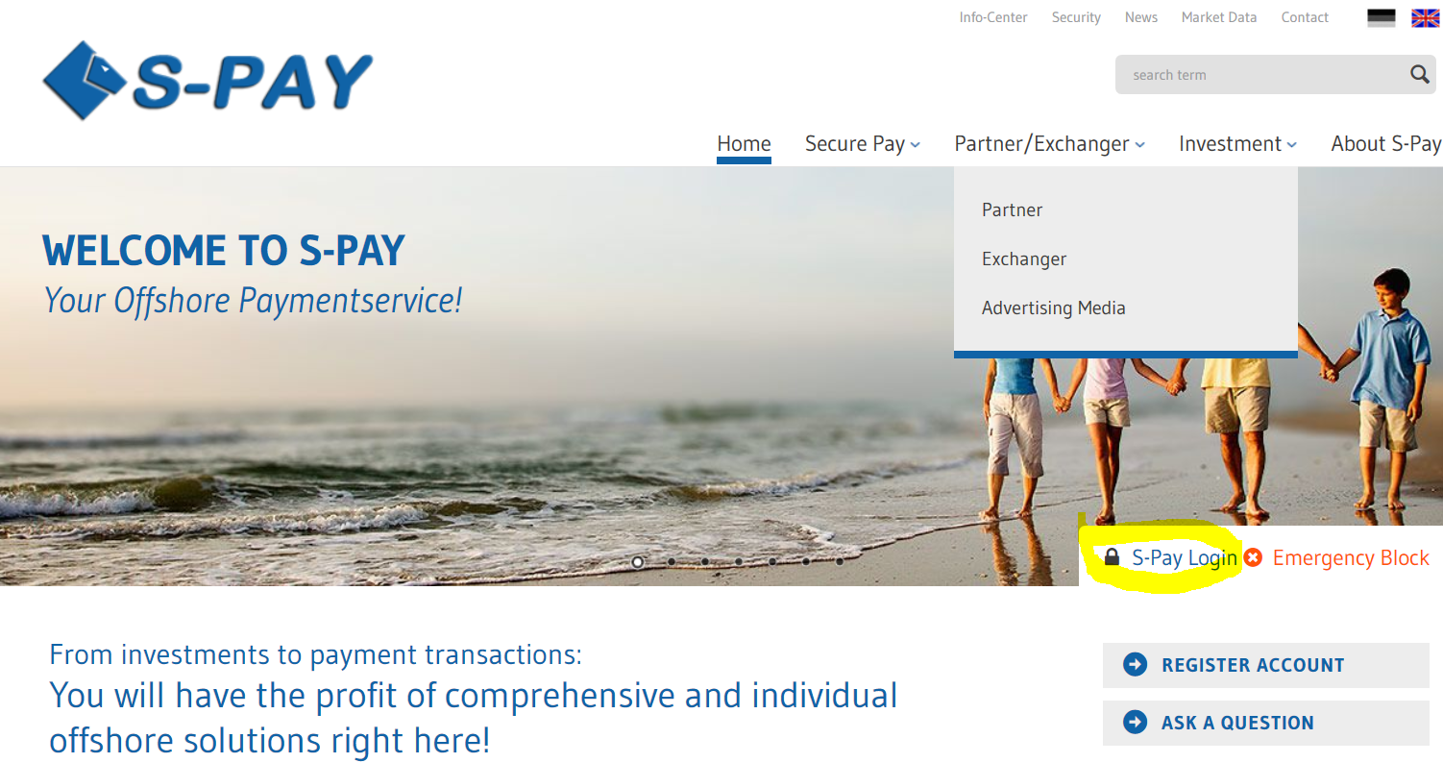
The following website will be shown:
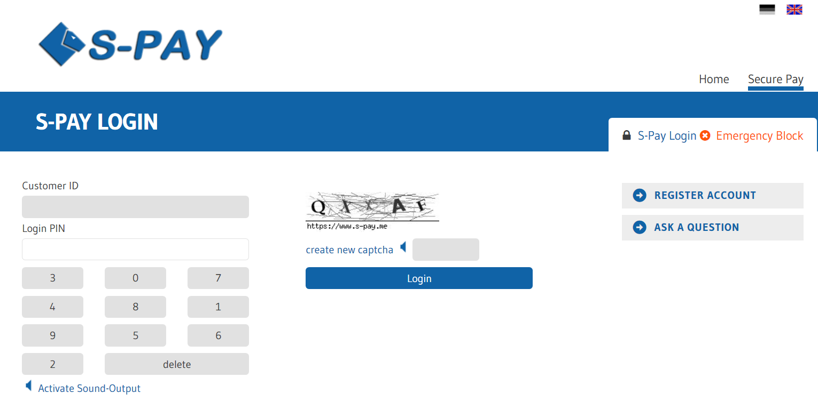
As “Customer ID” you need to enter the ID which was set for your new account by our system. Directly under this you need to enter your “Login PIN”which you also received while registration. The PIN is only apply-able with your mouse. You simply use the displayed virtual keyboard. A direct entry using your hardware keyboard is not able due to security reasons. Right next to it please enter the shown captcha code and click “Login”. If all was correct the Login-Page 2 will be shown:
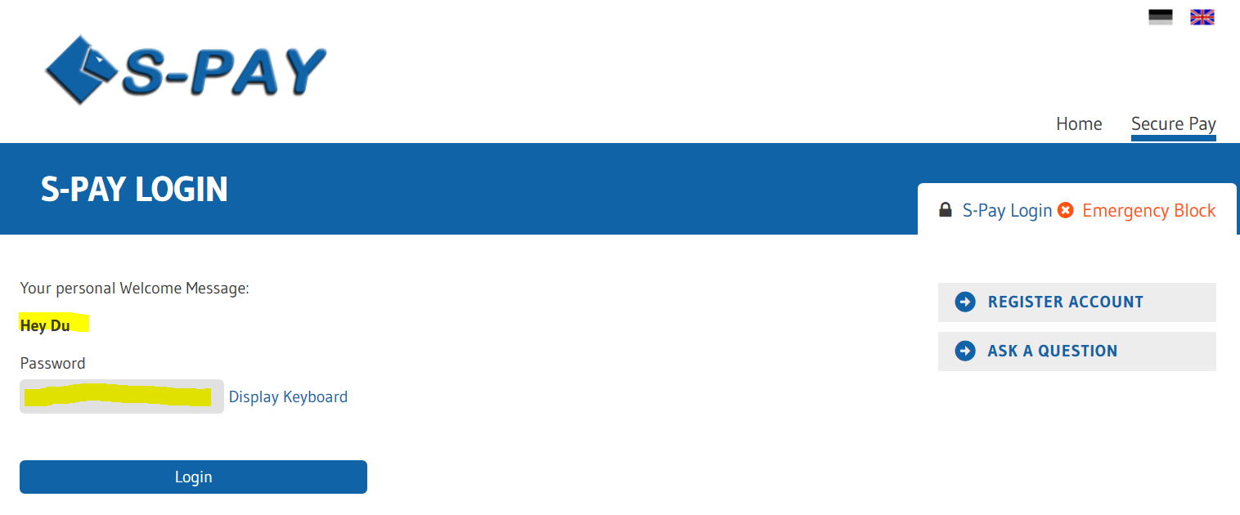
At this page you will see your personal welcome message you just entered while signing up to our service. In our example like shown above the customer entered “Hey Du” as his own personal welcome message. If YOUR OWN welcome message you entered is NOT shown you are not at the real S-PAY website and are probably visiting a phising website where the “bad guys” want to save your own log-in information. Stop the log-in process immediately, close your browser and contact the S-PAY support team! Only the real S-PAY system will know your own personal welcome message! Nobody else!
If your welcome message was shown correctly you can be sure to be directly at the valid S-PAY website. So you are now free to enter the password you entered while your sign up process. Also you are able to use the virtual keyboard again but that's optional. If done click “Login”.
If all went well you will now see the following website: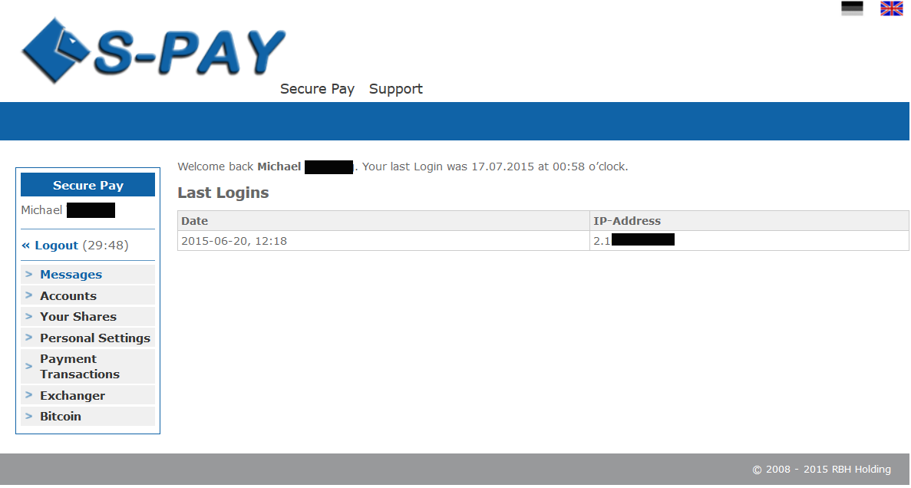
On the welcome page you will see the following information:
In the middle of the screen you will see date and time of your last log-in. Also the last IP address used is shown. If there are any message directly from S-PAY service those will also be shown in this area. At the left side you see the menu box. At the top of it you will see your own name. Directly under it there is the log-out button. Right to it a counter will run showing minutes and seconds. This will start again after every single action you do in your back-office. If you were not active within 30 minutes the system will automatically log you out for security reasons.
Directly under the log-out button all available navigation entries are shown to browser all functions of our payment system. The menu entry “Exchanger” is only available to customers which offer exchaning services for S-PAY currency.

Important note regarding your online banking:
Our S-PAY banking system works with a so called security token to avoid that malware or other viruses are able to set automatic actions. Therefore all external navigation in our website will lead to immediate log-out! So:
Please always just use the navigation on the left side of our website. All browser-own elements like back or forward will lead to an automatic log-out!

Creation of a new currency account
In the left menu bar click “Accounts” and then “New Account”. The following website will be opened:
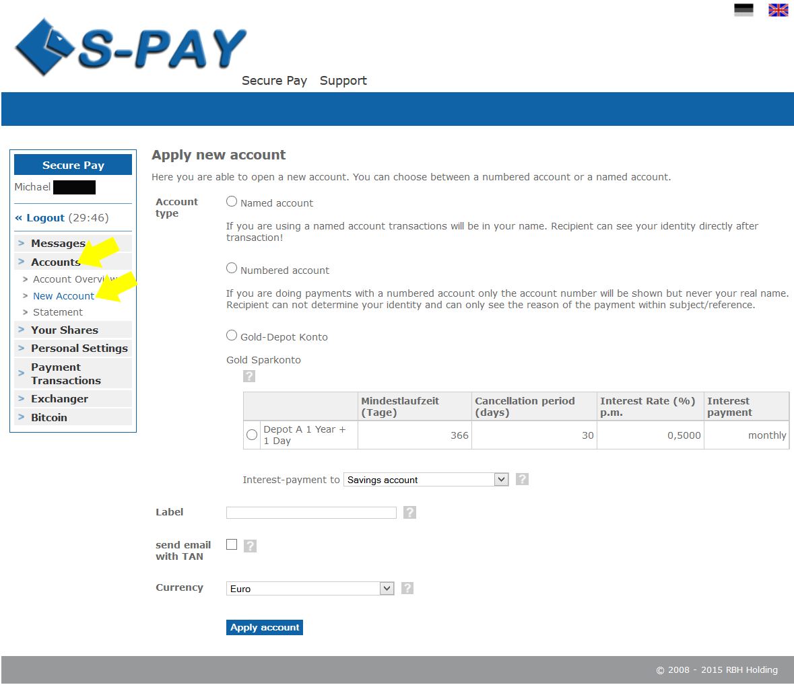
You are able to add unlimited accounts with several currencies. Lets face the detailed possibilities:
- Account Type
  - Named Account
Using this kind of account your whole name will be shown to the recipient of any transaction you do.
  - Numbered Account
Using this type of account no name will be transmitted. The recipient therefore is just able to identify the payment by looking at the payment purpose.
  - Spot and Investment Accounts
If offered you are able to create several spot and investment accounts with our service. The shown products inhere will vary depending of the actual offered services.
- Label
Give your new account a name of your own choice. Examples could be “ Dollar 1 Daughter”, “Dollar Business” or any other kind of label.
- Send email with TAN
If you mark this check-box you will receive an email with a valid TAN every time you do a transaction with which you need to legitimate the transaction process.
- Currency
Select the currency of your choice. Possible currencies are: Dollar, Euro, Bitcoin or Gold (Aurum).

Notes about account currency:
Please be advices that S-PAY does NOT support transactions between different currencies. If you want to send Dollar but just hold an Euro account you are not able to do so! Therefore we refer you to add several accounts with different currencies. An exchange between such internal currencies is offered by external exchanging services. Bitcoin does not need any external exchanger and can be deposited and withdrawn directly.
If you filled out all fields simply click on “Apply Account”. The following site will be shown:
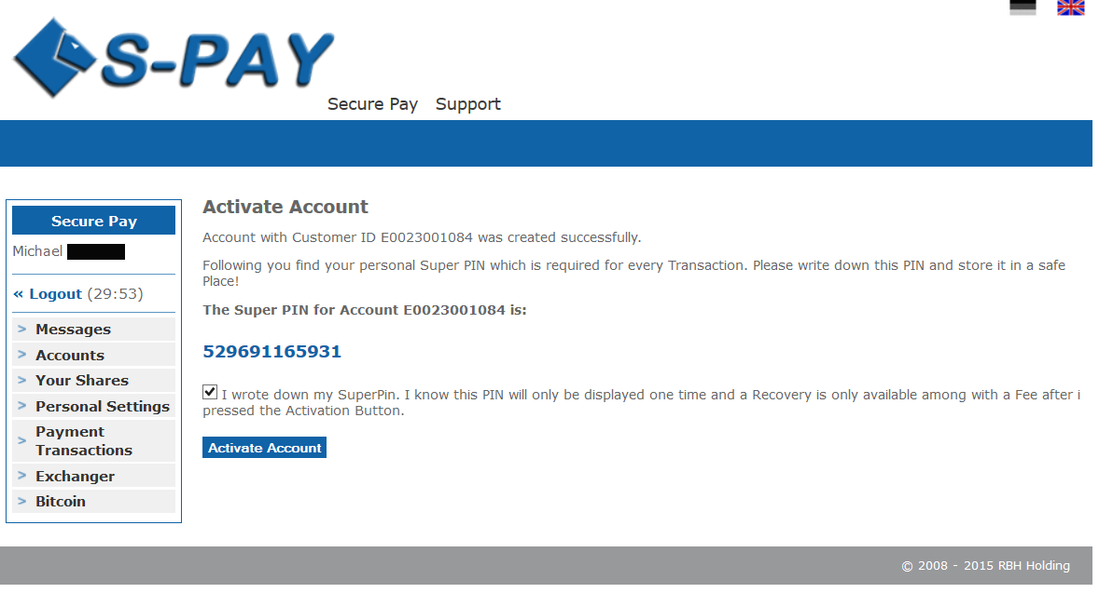
At this page you will receive your very own account number for the newly created internal currency account. It is absolute necessary that you write down the Super-PIN which is shown in blue! This PIN is only displayed once and can not be reconstructed. If you loose this PIN you are just able to deactivate the specified account by contacting our support team. After that you are able to re-activate the account again and a new PIN will be shown. Therefore store your Super-PIN always at a safe place.
If you wrote down your PIN check the confirmation mark. A button will show up telling you “Activate Account”. After clicking it your new currency account will be added into our system and you are able to see it by looking at your account overview:
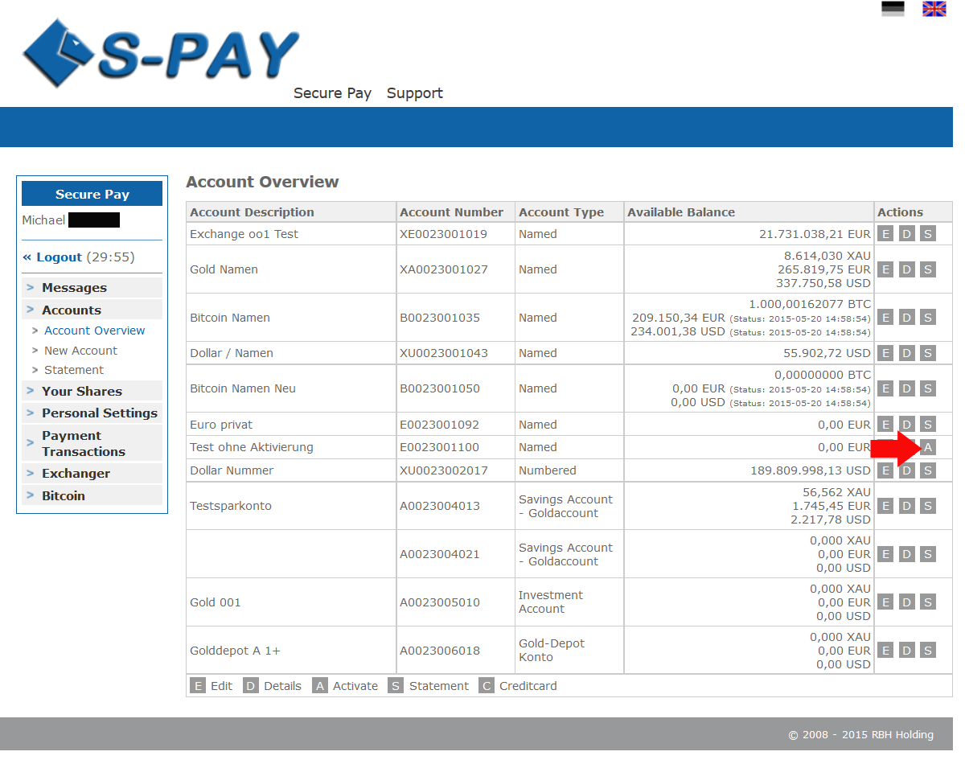
If something went wrong while activation of your newly created account or you contacted the support team to deactivate it after you lost your Super-PIN you will see an “A” behind the account. Click on it and you will be lead to the activation page like shown before to activate your account.

Notes regarding account numbers:
In S-PAY your currency account numbers are also referral ids at the same time. If you want to refer new customers to our online payment system you are free to use any of the created currency account. All commissions will be directly paid to this account in real-time too. All information about the S-PAY referral program can be found here: https://www.s-pay.me/de/secure-pay/referral-programm.html
After creation of your first account you are able to receive payments immediately. To send payments to other customers or service providers you now need to deposit into your account:

Deposits to your S-PAY currency accounts:
To deposit directly into your account the following possibilities are offered:
- Transactions from other S-PAY customers
To receive a payment simply tell the customer who wants to send you funds your own currency account number. For automatic receiving of payments we offer a Shopping Cart Interface (SCI) and an API. More information can be found here: https://www.s-pay.me/de/secure-pay/api.html

- Buying S-PAY funds through external exchanging services (Exchanger)
On our portal page by visiting https://www.s-pay.me/de/partnerexchanger/exchanger.html you will find validated and legitimated exchanging services which you are free to use to purchase S-PAY funds in example via bank wire transfers.

Notes regarding exchangers:
“Exchangers” are companies which are not owned by S-PAY. Please take notice that S-PAY is not able to give any support regarding deposits and withdrawals using external exchanging services. Also be advised that S-PAY calculates a fee of EUR 0.30 + 1.00 % (max. EUR 3.99) for receiving a payment and if you send funds out of your own account a fix EUR 0.30. So if you plan to receive EUR 100 into your account please calculate the fees additionally.
If you now have some funds in your account you are able to send them to other S-PAY customers:

The first transaction:
Click on “Payment Transactions” and then choose “S-PAY Internal”. The following site will be displayed:
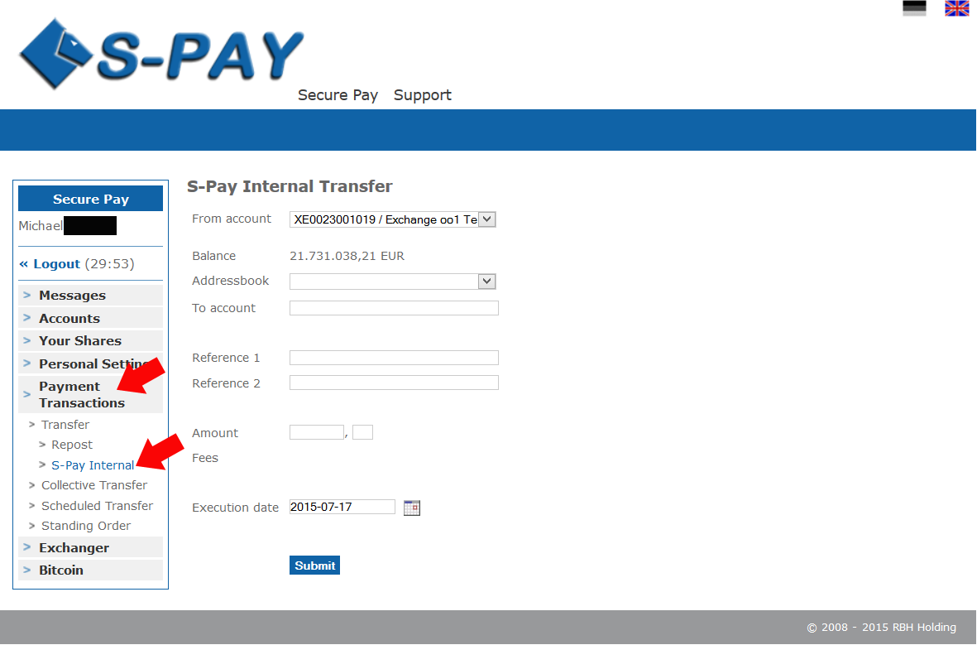

Choose “From account”. The actual balance of the chosen account will be shown directly under it. In “To account” you need to enter the currency account number of the recipient tho whom you want to send funds. “Reference 1 and 2” is your payment purpose. Here you enter the reason for your payment.
In the field “Amount” you will enter the amount of funds you want to send. Please take note that you need to enter the number before and after the decimal point separately. Directly under the amount will will then see the fee which will be calculated for this specified transaction. If you want to set a specific time when exactly this transaction should be done you are able to do so by using the “Execution date” option. If you want to send funds immediately simply leave it as it is.
Click on „Submit“.
The following screen will be shown:
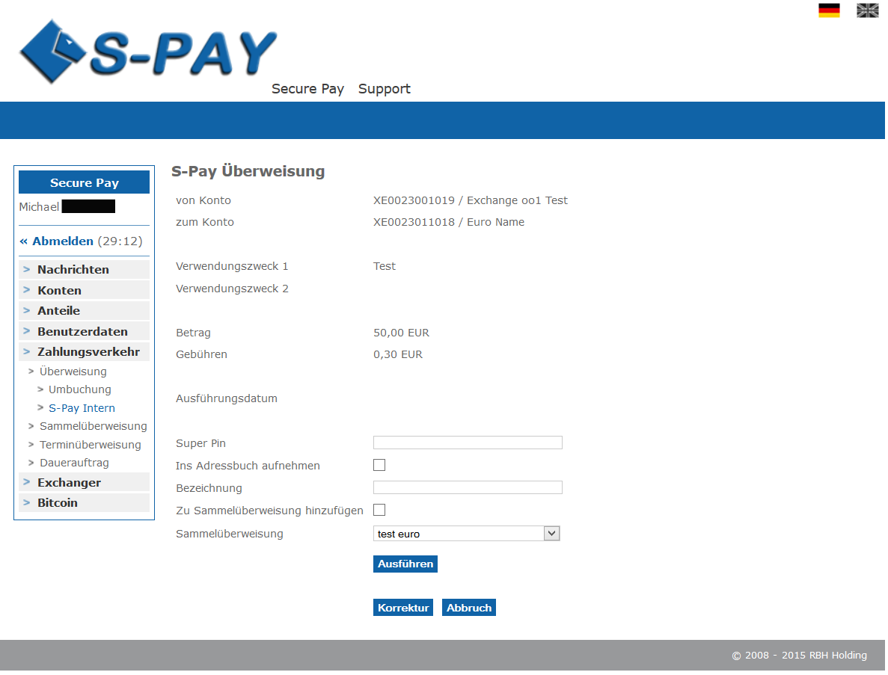
All information regarding the actual transaction are shown as a summary again. If something went wrong simply click on “Correct” and you will be lead to the site before. If the summary looks good to you you simply need to enter the Super-PIN code which belongs to the account where you want to send funds from. All okay? Click “Submit” and the following confirmation page will be shown:
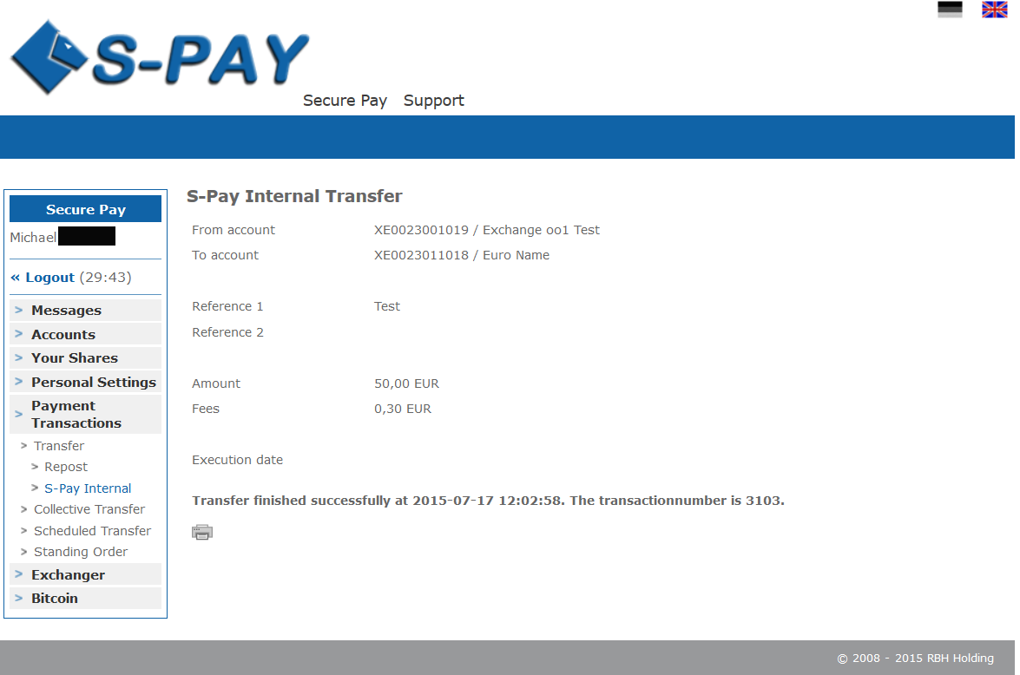
By clicking the printing sign you are able to print this confirmation directly with your local printer device. Your transaction was booked in real-time and you are able to do next transactions.

Notes regarding internal transactions:
As you may have already noticed you are able to include the recipient into your own personal address-book before submitting the transaction to our system. While your next transaction you will be able to choose from your address-book and the necessary data will be inserted automatically into the determined fields. Address-books are held separated for each currency account.
!Attention!
Internal transaction are final and non-refundable! Make sure you inserted the correct account numbers while doing any transactions. If you inserted the wrong details its up to the recipient to send you the funds back.
S-PAY is not able to do that!

Closing words
After going through that tutorial step by step you should now be able to work with S-PAY. The system offers a bunch more additional functions which you are now able to explore and you should do that.
We wish you a lot of fun using S-PAY for your online payment needs and for sure for your business too!

